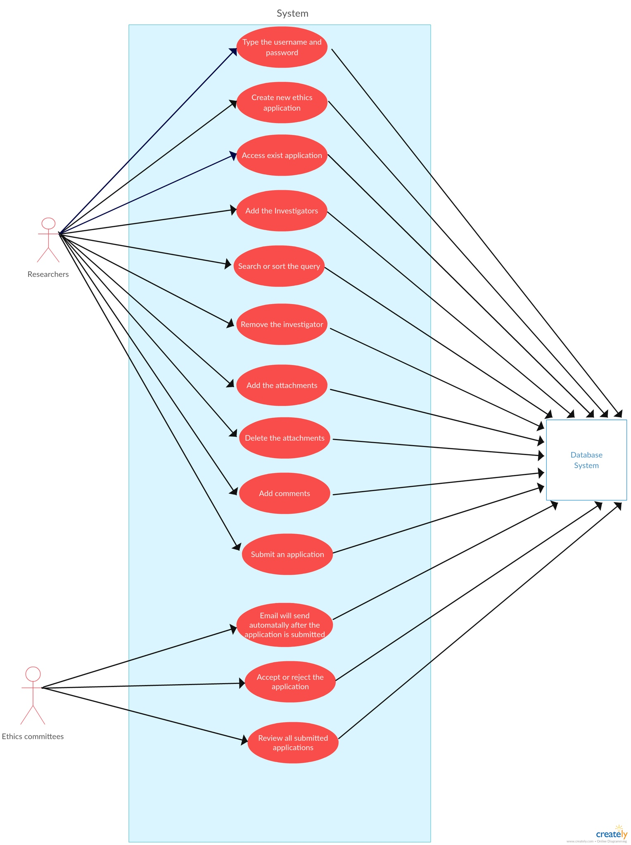

Use case outline

Brief Description

This use case allowed the researchers to enter their username and password to enter the ethics system. The researchers can develop the application and submit the application within the system. When the application is submitted, the email will automatically send to the applicant. The data and each application will store in database.

1. **Type the username and password**

Basic Flow

1. Go to the ethics website.
2. Type the username in the ‘Username’ space provided.
3. Type the password in the ‘Password’ space provided.
4. Press Log in button.

Alternative Flow

1. Invalid username
2. Invalid password
3. Quit the website
4. **Create new ethics application**

Basic Flow

1. After entered the username and password, the home page will be see.
2. Press Application button
3. Press new Application
4. The new ethics application is generated.

Alternative Flow

1. The new application can’t generate.
2. The new application created as the initial draft status.
3. **Access exist application**

Basic Flow

1. Go to the home page
2. Press Application button
3. Press All Applications

Alternative Flow

1. No any existing applications.
2. **Add the investigator**

Basic Flow

1. Enter one of the application
2. On the left side there have a button call investigator
3. After that press add investigator button
4. Type the name or id of the investigator that you want to add
5. Select the correct investigator name and ID from the list.
6. Click OK

Alternative Flow

1. Can not find the investigator by searching their name or ID.
2. Some investigator may have same last name.
3. **Search or sort the query**

Basic Flow

1. Go to the left hand side of the home page of ethics system
2. Click Application
3. Click view all
4. On the top there are a space that allows user enter keyword to find the application also it can sort the application depend on different aspects, such as date etc.

Alternative Flow

1. There is no match application base on the user entered.
2. Click to other function in the system.
3. **Remove the Investigator**

Basic Flow

1. Enter one of the application
2. On the left side there have a button call investigator
3. Can see the current assigned investigator
4. At the end of the investigator name, there are a remove button

Alternative Flow

1. The investigator can’t delete.
2. **Add Attachments**

Basic Flow

1. Enter one of the application
2. On the left side there have a button call attachment
3. Press add attachment
4. It shows there are a button call browse, it means that it can upload a file from the user’s computer.
5. Press OK

Alternative Flow

1. The attachment can’t be added because of the file capacity.
2. A number of attachment attached to the application lead to the attachments can’t be added.
3. **Delete Attachments**

Basic Flow

1. After adding the attachments, the user can see all of the attachments of the application.
2. For each attachment, in the end there are a remove button that allow user to delete the attachments.

Alternative Flow

1. The attachment can’t be deleted.
2. All the attachments are removed.
3. **Add Comments**

Basic Flow

1. Enter one of the application on the home page
2. On the left side there have a button call New Comment
3. The user can type the comments related to the application.
4. After finished typing the comments, press OK.

Alternative Flow

1. The word space that the user has entered is over the word space of the column provided.
2. The comments can’t be added to the application.
3. The comments can be modifying later.
4. **Submit the application**

Basic Flow

1. Enter one of the application on the home page
2. On the left side there have a button call Submit
3. Press the Submit button
4. A message box will be show and press OK
5. The application is submitted.

Alternative Flow

1. The application can’t submit because there are some parts missing or did wrong.
2. **Email will be send automatically**

Basic Flow

1. After submitted the application, there will be an email send to the researches and the ethics committees.
2. The email is about the status of application, for example the query is submitted, completed.

Alternative Flow

1. The email can’t be send to the researchers.
2. The email will send after a long time.
3. The email will send a short period of time.
4. **Accept or Reject the Application**

Basic Flow

1. Type the username and password
2. After that, the home page of ethics system is showed.
3. The ethics committees can view all application from different researchers.
4. For each application, there are a tick or cross at the end of the application.
5. The tick means that accept the application, the cross means that decline the application.

Alternative Flow

1. Some application can be first reject and then the committees change their mind and accept the application.
2. The committees can view the particular application and decide whether they will accept or reject the application.
3. **Review all submitted applications**

Basic Flow

1. Type the username and password
2. After that, the home page of ethics system is showed.
3. The ethics committees can view all application from different researchers.

Alternative Flow

1. The submitted applications appear in different order.
2. Some duplicate application can be deleted.
3. Each researcher can submit more than one application.